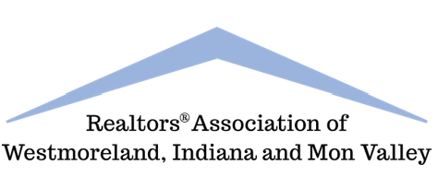
Industry Partner Membership Application
Realtors Association of Westmoreland, Indiana & Mon Valley
500 North 12th Street, Lemoyne, PA 17043
Telephone: 724-837-9305 Fax: 717-561-8796 Email: info@realtorswim.com

I hereby apply for “Industry Partner” membership in the above-named board/association, and enclose my check in the amount of $ , which I understand will be returned to me in the event I am not accepted to membership. I further agree that my act of paying dues shall evidence my initial and continuing commitment to abide by the constitution, bylaws, rules and regulations of the board, all as from time to time amended.

ARTICLE IV – MEMBERSHIP
Section 1 (c) – Industry Partner Members. Industry Partner Members shall be real estate owners and other individuals or firms who, while not engaged in the real estate profession as defined in paragraphs (a) or (b) of this Section, have interests requiring information concerning real estate, and are in sympathy with the objectives of the Board.
Finally, I consent and authorize the board, through its membership committee or otherwise, to invite and receive information and comment about me from any member or other person, and I agree that any information and comment furnished to the board by any member or other person in response to any such invitation shall be conclusively deemed to be privileged and not form the basis of any action by me for slander, libel, or defamation of character.

To: Realtors Association of Westmoreland, Indiana & Mon Valley

(Board/Association of Realtors)

Name of Representative_

(Please print)
Title_

Firm Name_

Home Address:

Home Phone:_
Email:

Business Address:

Business Phone:_
Fax:
I hereby submit this application for your consideration and I agree that, if accepted for membership in the
board, I will pay the fees and dues as from time to time established.

Signature:

Date:_____________________________________

